File, Options, and Help menus Names of your current files pop-up ToolTip context help
symptom text display toolbar provides shortcuts

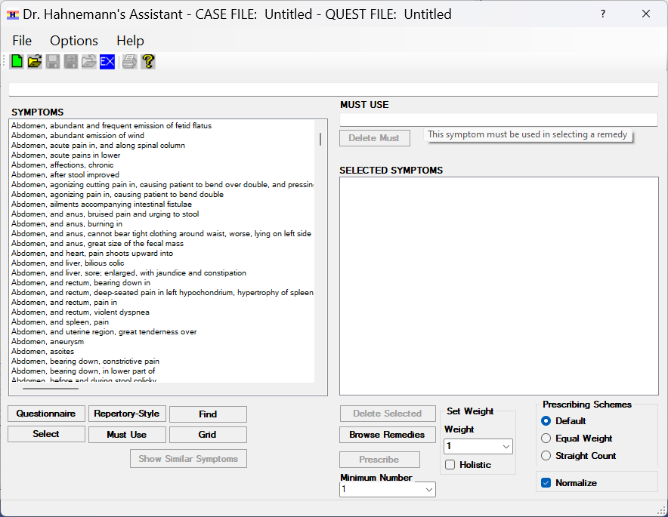
this dropdown assigns weight to symptoms
use these buttons to search for symptoms
select symptoms from this list with these buttons selected symptoms appear in these boxes

Figure 1 – Main Form

